Keeping Interactive Notebooks in Science
The Right Side

Interactive notebooks will be used in this class daily to help you learn and remember important scientific concepts. Why do they work? This notebook style uses both the right and left brain hemispheres to help you sort, categorize and remember and creatively interact with the new knowledge you're gaining. The more you process information the more you begin to understand it. This leads to longer retention.
Right Side

What goes on the Right Side? Input goes on the right side!
Input is all the information that you are supposed to learn. Some examples of input are: thrilling notes: lectures, guest speakers, text or other sources; vocabulary words; video and film notes; teacher questions; readings: questions and answers and sample problems.

- Always start the page with the date and title at the top of the page.
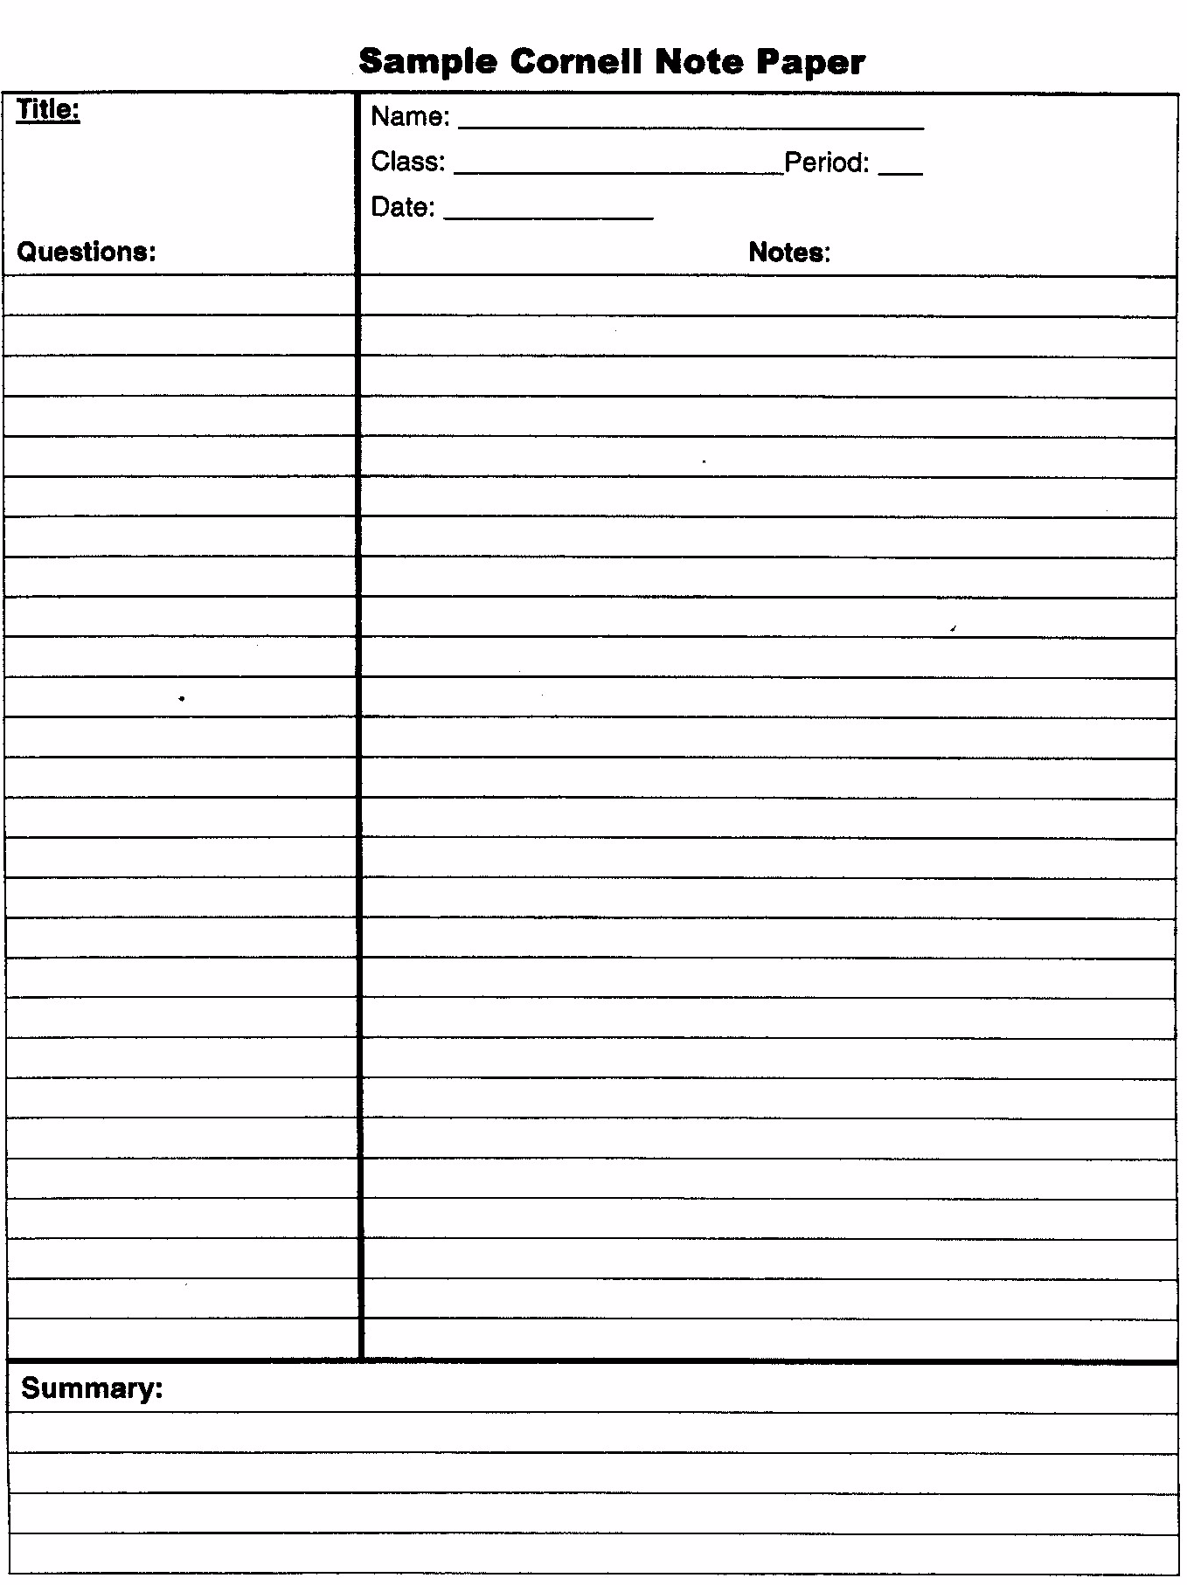
- Right sides have odd numbered pages.
- The right page is for writing down information you are given in class.
- Use Cornell style notes for lecture, discussion, text, etc. Write up your study questions as soon as possible.
- Write legibly. Use highlighting color to make important information stand out.
- Write summaries at the bottom of each page of notes to reduce the amount you have to study.

Sample Cornell Style Notes Without the Summary

Experimental Design is a process that can be followed to develop an experiment from the choosing of the independent variable, dependent variable, control and constants and the writing of a procedure.

Brainstorm all possible relationship that are to be tested.
Identify the relationship to be tested.
Identify the variable that will be changed (independent) and the variable or variable to be measured (dependent).
Develop a hypothesis using and If then statement.
Determine and list all the variable that will be held constant.
Identify a control used to compare to the dependent variable.
Create a table showing how the data is to be documented during experimentation.
Develop a list of equipment needed to conduct the experiment.
Write the procedure.

Experimental Design
Billy JonesSeptember 3
PhysicsPeriod 3

What variables should be considered when developing a experiment?

Why is it important to use a well-designed experiment?

How do the steps used in developing an experiment aid in effective experimenting?

Develop an experiment to test one of the relationships explored in class.

v

